Planning for Iteration One

# Iteration Goal

The goal of the first iteration was to create art for the new models in the Javascript game. I needed to draw pixelart for the Car model for the player and the Roadcones which the player would be collecting. The Lava was also reskinned to represent liquefaction. Once the art is done I need to figure out how the game loads the art and change it to work with the new pixelArt. Also want to work on theming the page and getting some basic CSS styling done.

# Planned Tasks

1. Create new pixel art (Car, Roadcone, Liquefaction and Road)
2. Figure out how the game loads art and change it to work with the new pixel art
3. Create layout and basic CSS for the page

|  |  |  |  |
| --- | --- | --- | --- |
| **Estimated Time** | Create Pixel Art | Figure how game works with art | Basic layout and CSS |
| Time (hours) | 2 | 2 | 1 |

|  |  |  |  |
| --- | --- | --- | --- |
| **Actual Time** | Create Pixel Art | Figure how game works with art | Basic layout and CSS |
| Time (hours) | 3 | 2 | 1 |

## StandardJS

Game.js

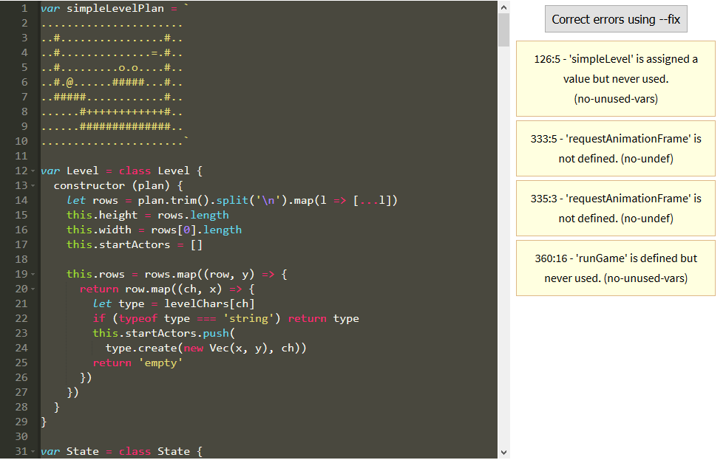

Canvas.js

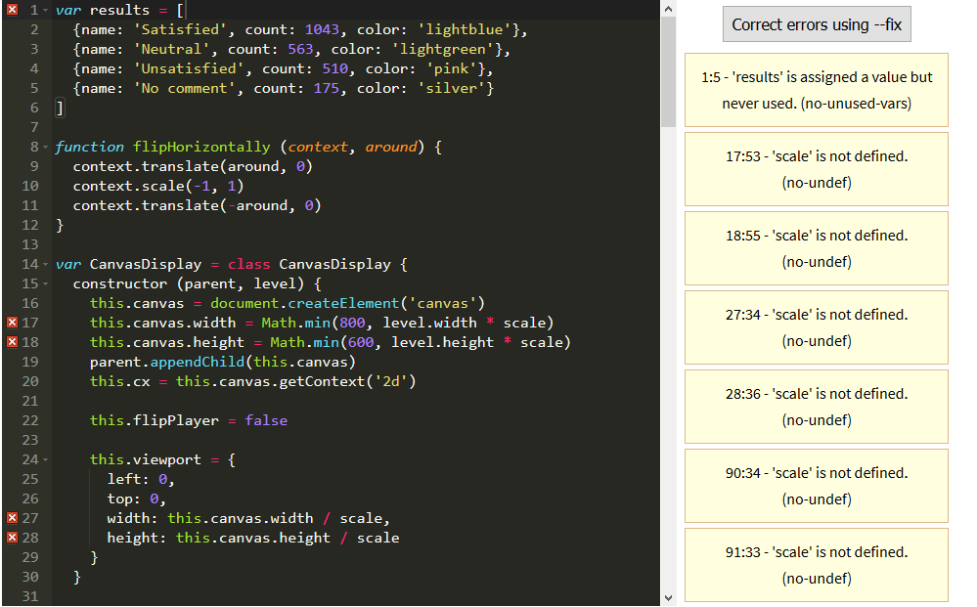

Please note that all remaining errors were just regarding no-unused-vars and no-undef.

## Mistakes Analysis

I initially drew lots of the art at too low of a resolution and not using a vector program so I had to redraw lots of it again so it would be big enough for the game. This is why the actual time for this is higher than estimated. Initially I completely misunderstood how the texture tiling worked which led to time being wasted figuring that out. I eventually worked out how to set the width and height correctly for the new art in canvas.js and also changed its virtual size in game.js.

## Lessons Learned

Drawing art in a vector illustration program allows me to scale it infinitely meaning the resolution will never be a problem and nothing will have to get redrawn. I now understand how the tiling works with multiple textures etc so if I’m ever making a side scrolling game in the future this will be useful.